# Homework #6: User Management

|  |
| --- |
| * This is an individual assignment, and is worth 20 points. * The due date is Tuesday, March 12th, midnight. * You need to provide your answers to the “Homework #6 - Tasks.docx” file. Change the file name following the naming convention suggested below. * Naming convention is as follows: homework, underscore, last name, first initial, and extension (e.g., Homework #6_ImG.docx). If you do not follow the convention, I will deduct 1. * Do not copy any of the sample screenshots provided as illustrations. * The database for the assignment - AdventureWorks2016CTP3 – in installed on our Proxmox server. You should download this document after you login to the Proxmox server. * You should answer the questions in blue. * You will get deductions if the requested screenshots are not provided. |

# Task #4. Assigning User Mappings to Fixed Database Roles

## A. Assigning a user to a database role

## B. Verifying the results

5) Does it fail? Show the result in a screenshot. Describe your observation and explain why it fails.

This fails because we assigned DB_denydatawriter role to TestUser-A. This means the user cannot insert, update, delete access to al user tables.

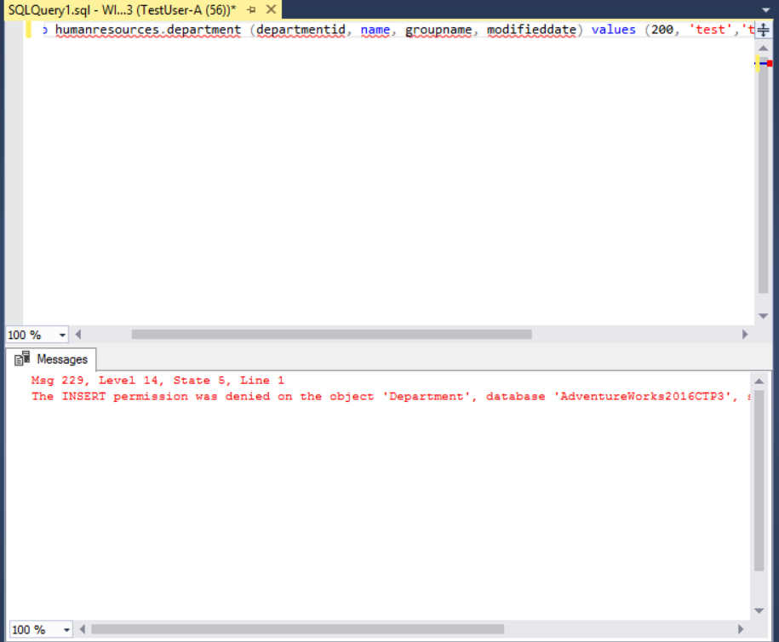

10) Does it fail? Show the result in a screenshot. Describe your observation and explain why it fails.

This fails because we assigned DB_denydatareader to TestUser-B. This means the user does not have select access to all user tables.

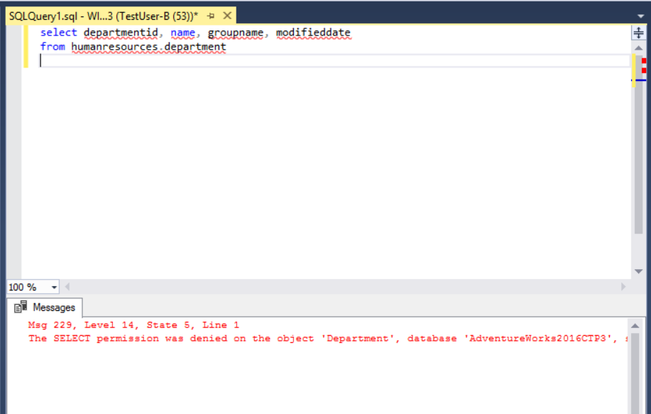

# Task #5. Creating a Custom Database Role

## A. Creating a custom database role

## B. Verifying results

4) Does it work? Show the result in a screenshot. Describe your observation and explain why it works.

This works because we granted Select permission for TestUser-C on the HumanResources.Department table.

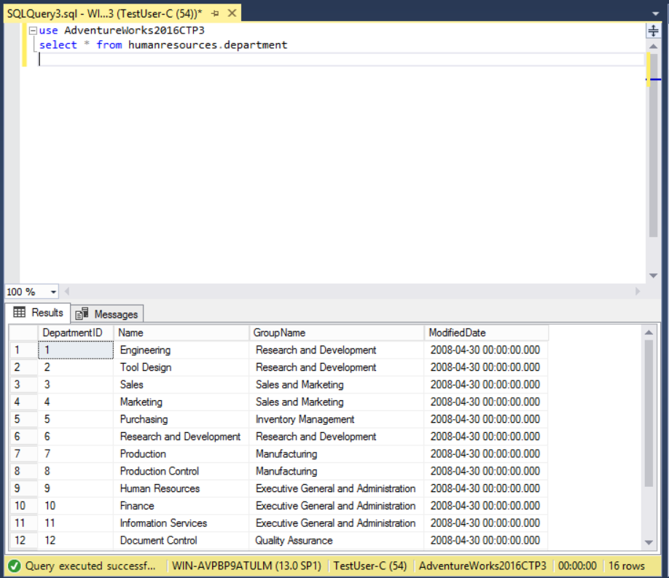

5) Does it fail? Show the result in a screenshot. Describe your observation and explain why it fails.

This fails because the only permission granted was select and this is trying to insert onto HumanResources.Department table.

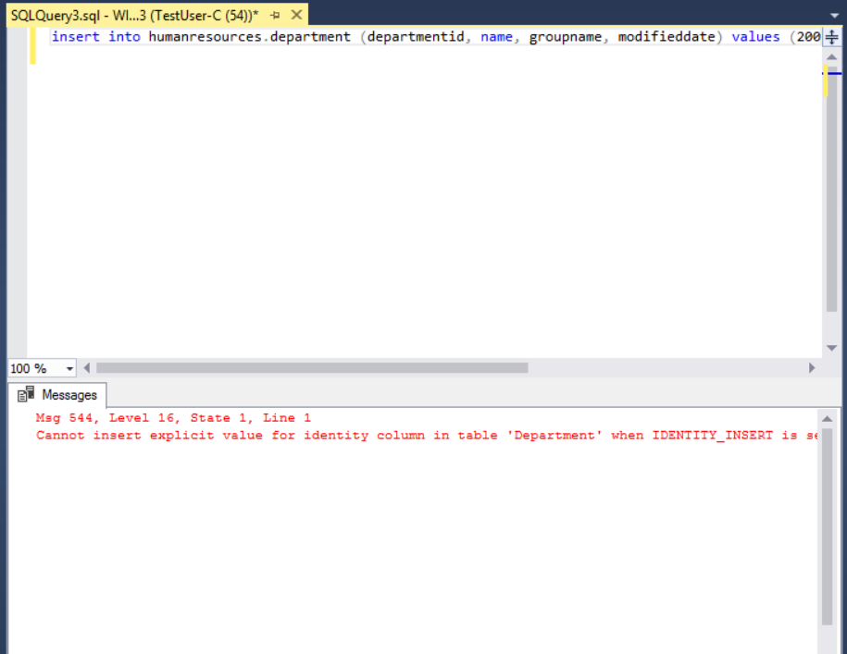

# Task #6. Creating an Application Role

## A. Creating an Application Role

## B. Verifying Results

2) Does it fail? Show the result in a screenshot. Describe your observation and explain why it fails.

This fails because TestUser-B still has a DB_denydatareader role which means select access is denied to all user tables. The application role is also not activated yet

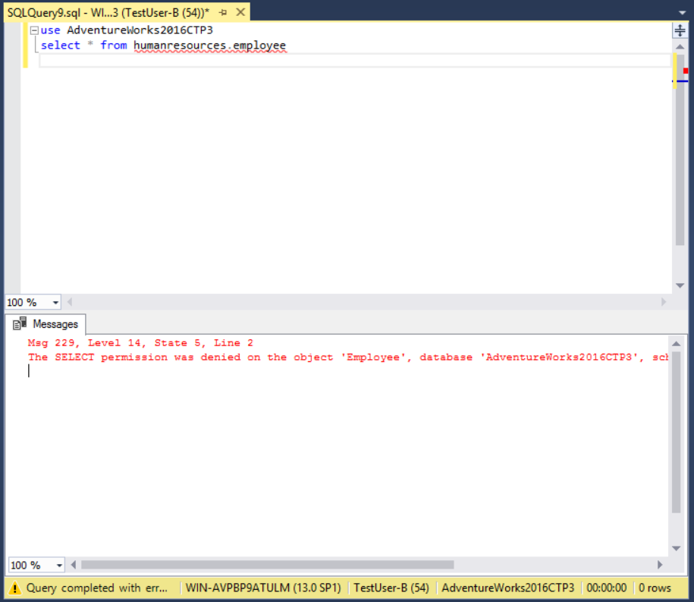

4) Does it work? Show the result in a screenshot. You have to click on Results to view the results. Describe your observation and explain why it works.

This works because we have activated the application role so now the select grant is active.

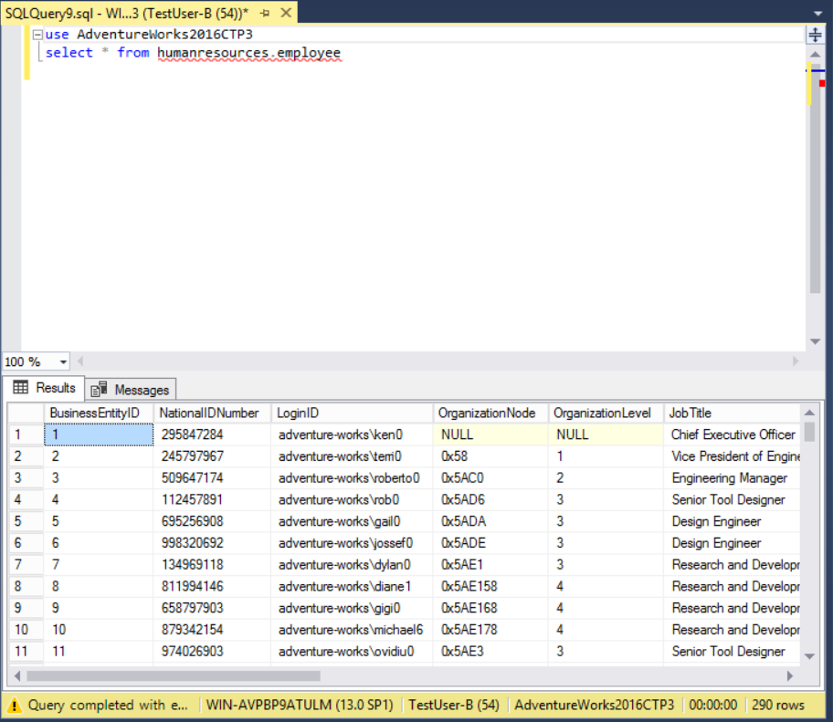

# Task #7. Assigning Permissions

9) Does it work? Show the result in a screenshot. Describe your observation and explain why it works.

This works because we granted select permission for Person.Address table for TestUser-A.

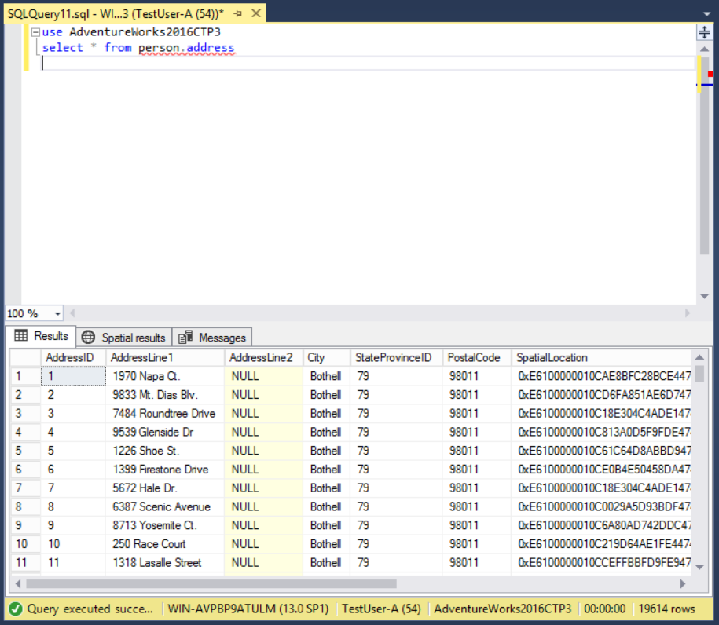

13) Run the previous query. Show the result in a screenshot. Describe your observation and explain why it fails.

This no longer works because we took away the Select permission on Person.Address table from TestUser-A by unchecking the select box and this user already has DB_denydatawriter.

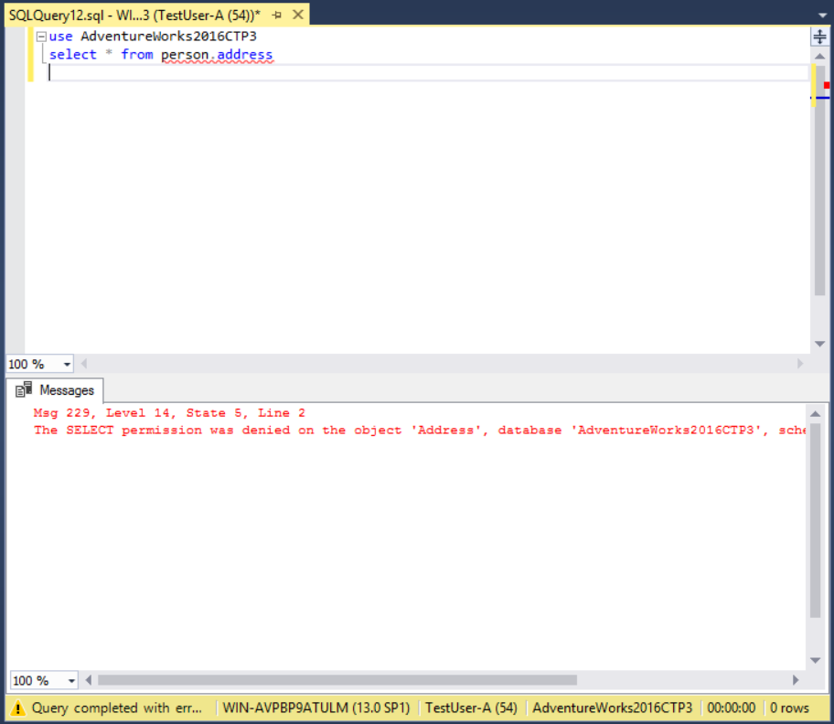

15) Run the previous query. Show the result in a screenshot. Describe your observation and explain why it works.

This works because TestUser-A is now part of db_datareader which means they are granted select access to all user tables.

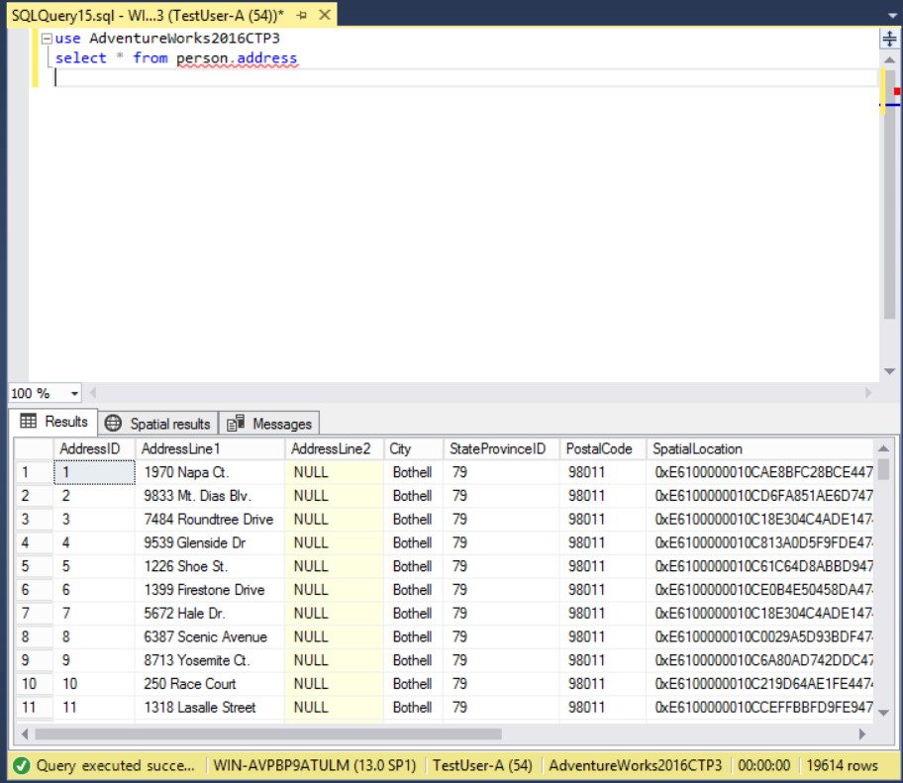

19) Run the previous query. Show the result in a screenshot. Describe your observation and explain why it fails.

This did not work because we denied Select permission.

